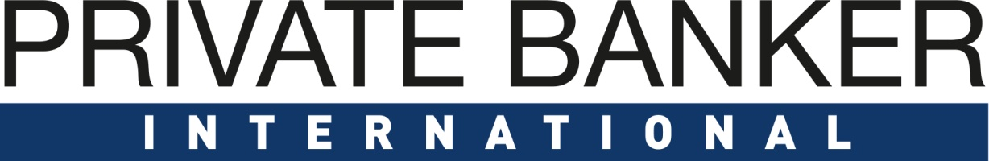

Private Banking: Germany

Awards 2019

Entry Form

PART A – must be received by 22.02.2019
Company Details
Company Name
Company Address (including Postcode)
Contact Person
Contact Details
Submission Details
Item | Details
Tick Submission Award Categories

 | Outstanding Family Office Proposition in Germany
 | Outstanding UHNW Offering in Germany
 | Outstanding Wealth Management Technology Provider in Germany – Middle and Back Office (Vendor)
 | Excellence in Customer Experience (Technology Provider)
 | Outstanding Front-End Digital Solutions Provider (vendor)
 | Outstanding Boutique Private Bank in Germany
 | Outstanding Private Bank Germany – International Players
 | Outstanding Private Bank Germany – Domestic Players
Declaration  I have read the information in the notes below and as provided in the Awards Information Pack. I am submitting this entry in accordance with those instructions. I guarantee that the information provided is true and correct at the point of submitting this entry.  Notes: For Additional Details please refer to the information pack  - The deadline for completed and signed entries is 19.02.2019 Please ensure your form has been emailed to arena-international.com  - Please fill one form for each category entered. |  | ………………………………………  Authorised Signatory
PART B – must be received by 22.02.2019
Award Snapshot
(Please describe in between 500 – 1000 words or less why your programme or product should be nominated in this category. Please refer to the bullet points below the category when outlining your rationale.) Graphs and pictures can be copied into this document.

Website URL
Any other details you wish to share

Please send this form & any supporting documents to events@arena-international.com by 22.02.2019

